**OnlineKabadi.in**

A

Report of project

Submitted in Partial Fulfillment of the Requirements for the Degree of

BACHELOR OF TECHNOLOGY

in

**COMPUTER SCIENCE & ENGINEERING**

By

**Paras Jain (1709510025)**

**Adesh Singh (1709510005)**

**Gagan Singh Dhami (1709510013)**

**Rishabh Chaudhary (1709510032)**



**DEPARTMENT OF COMPUTER SCIENCE & ENGINEERING**

**MGM’s College of Engineering & Technology, Noida**

**July, 2021**

***DECLARATION***

*I hereby declare that this submission is my own work and that, to the best of my knowledge and belief, it contains no material previously published or written by another person nor material which to a substantial extent has been accepted for the award of any other degree or diploma of the university or other institute of higher learning, except where due acknowledgment has been made in the text.*

*Signature*

*Name: Adesh Singh*

*Roll No. 1709510005*

*Signature*

*Name: Paras Jain*

*Roll No. 1709510025*

*Signature*

*Name: Gagan Singh Dhami*

*Roll No. 1709510013*

*Signature*

*Name: Rishabh Chaudhary*

*Roll No. 1709510032*

*Date:*

## **CERTIFICATE**

This is to certify that Project Report entitled “**OnlineKabadi.in**” which is submitted by **Paras Jain, Adesh Singh, Gagan Singh Dhami and Rishabh Chaudhary** in partial fulfillment of the requirement for the award of degree B. Tech. in Department of Computer Science and Engineering of AKTU University, is a record of the candidate own work carried out by him under my/our supervision. The matter embodied in this thesis is original and has not been submitted for the award of any other degree.

**Date:**  **Supervisor:**

**(Mrs. Karamjeet Kaur)**

ACKNOWLEDGEMENT

*It gives us a great sense of pleasure to present the report of the B. Tech Project undertaken during B. Tech. Final Year. We owe special debt of gratitude to Professor* ***Karamjeet Kaur, Department of Computer Science & Engineering****, MGM College of Engineering & Technology, Noida for his constant support and guidance throughout the course of our work. His sincerity, thoroughness and perseverance have been a constant source of inspiration for us. It is only his cognizant efforts that our endeavors have seen light of the day.*

*We also take the opportunity to acknowledge the contribution of Professor* ***Mrs. Archana Sar, Head of Department (Computer Science & Engineering)****, MGM College of Engineering & Technology, Noida & Dr. Sanjay Shrivastava for his full support and assistance during the development of the project.*

*We also do not like to miss the opportunity to acknowledge the contribution of all faculty members of the department for their kind assistance and cooperation during the development of our project. Last but not the least, we acknowledge our friends for their contribution in the completion of the project.*

*Signature: Signature:*

*Name*  *: Adesh Singh Name: Paras Jain*

*Roll No.: 1709510005 Roll No.: 1709510025*

*Signature: Signature:*

*Name*  *: Gagan Singh Dhami Name: Rishabh Chaudhary*

*Roll No.: 1709510013 Roll No.: 1709510032*

*Date* *:*

ABSTRACT

*Nowadays, if someone has to sell their scrap, then they have to wait for ragman to come and buy those scraps, and sometimes they don’t offer a good price for the scraps. Also, sometimes finding ragman is not an easy task customer has to wait for hours. Also, there are many other problems like: In OnlineKabadi.in, our executives are well educated, polite, friendly, and driven by a passion for customer service. They are well trained in work ethics and customer relations. Customers who sell their scrap at OnlineKabadi can rely upon to get a trustworthy price for all the scrap materials sold. To keep our customer's peace of mind we use a superior quality digital weighing machine. OnlineKabadi offers comfort and flexibility to our customers by providing doorstep pickup service and also Instant payment for their scrap. We have a dedicated pick-up service to collect your scrap materials directly from your doorstep and on a scheduled day and time. For us, the user or customer convenience is very important. So, we have developed a website known as OnlineKabadi, for the convenience of selling scrap.*

**TABLE OF CONTENTS**  Page

DECLARATION ................................................................................................... i

CERTIFICATE ..................................................................................................... ii

ACKNOWLEDGEMENTS .................................................................................. iv

ABSTRACT ........................................................................................................... v

LIST OF TABLES.................................................................................................. vii

LIST OF FIGURES................................................................................................ viii

CHAPTER 1 (INTRODUCTION, BACKGROUND OF THE PROBLEM,

STATEMENT OF PROBLEM etc.) .............................................................. 1

1.1. Literature review…………………………………………………………. 2

1.2. Problem defination.................................................................................... 5

1.3. Brief introduction of the project...................................................................... 8

1.4. Proposed modules………………………………………………………. 9

1.5. Hardware & Software requirements…………………………………………. 11

CHAPTER 2 (Systems Analysis and Specification) .................................... 13

2.1. . A functional model......................................................................................... 15

2.2. . A data model....................................................................................................... 17

2.2.1. ......................................................................................................... 19

2.2.2. ......................................................................................................... 20

2.2.2.1. ................................................................................................ 21

2.2.2.2. .......................................................................................... 22

2.3. . A process-flow model..................................................................................... 23

2.4. A behavioural model………………………………………………………… 25

2.5 . System Design

2.5.1 Technical feasibility

2.5.2 Operational feasibility

2.5.3 Economic feasibility

CHAPTER 3 (Module Implementation & System INTEGRATION) ................ 30

3.1. ................................................................................................................ 36

3.2. ................................................................................................................ 39

CHAPTER 4 (Testing and EVALUATION) ......................................................... 40

CHAPTER 5. (Task Analysis and Schedule of Activities)

5.1 Task decomposition ……………………………………

5.2 Project schedule ………………………………………..

5.3 Task specification: for each task, identify goals, inputs, outputs, estimated effort and duration, and task dependencies. ……………………………..

CHAPTER 6(PROJECT MANAGEMENT)

6.1 Meetings with supervisor…………………………………………………

6.2 Major risks and contingency plans ………………………………………….

6.3 Principal learning outcomes ……………………………………………….

APPENDIX A ......................................................................................................... 45

APPENDIX B ......................................................................................................... 47

REFERENCES... .................................................................................................... 49

**List of Figures**

|  |  |  |  |
| --- | --- | --- | --- |
| Sr. No. | Figure Number |  | Page Number |
| 01 | **1.1** |  | **09** |
| 02 | **1.2** |  | **11** |
| 03 | **1.3** |  | **14** |
| 04 | **1.5** |  | **18** |
| 05 | **1.6** |  | **21** |
| 06 | **1.7** |  | **22** |
| 07 | **1.8** |  | **28** |
| 08 | **1.9** |  | **30** |
| 09  10 | **2.0**  **2.1** |  | **31**  **34** |

**CHAPTER-1**

**INTRODUCTION**

This report contains detail description about the web application OnlineKabadi which is used by the customer in order to sell scrap online using our application. In India nowadays, if someone has to sell their scrap, then they have to wait for ragman to come and buy those scraps, and sometimes they don’t offer a good price for the scraps

**Purpose**

Purpose of this project is to save time for both seller and buyer. In order to build a trustful communication between ragman and seller we have created this application which is providing an online platform for both buyer and seller.

Selling scrap offline is very time consuming and sometimes leads to wastage of time for both customer and ragman. Till now communication between buyer and seller is not good which sometime leads to conflict.

**Scope**

Sometimes finding ragman is not an easy task for customers. So, customer has to wait for hours. So, this online platform will help customer to reach directly to ragman by following only three simple steps.

Image of every ragman in India very doubtful and they don’t allow ragman to enter their houses. They treat them as they are part of any thief community.

Today's time everything from clothing to food is available online but still one sector is unorganized i.e., scrap industry.

Scope of our application is very simple and customer friendly and created using simple technology and provide user friendly user interface.

**OBJECTIVES**

* In OnlineKabadi.in, our executives are well educated, polite, friendly, and driven by a passion for customer service. They are well trained in work ethics and customer relations.
* Customers who sell their scrap at OnlineKabadi can rely upon to get a trustworthy price for all the scrap materials sold. To keep our customer's peace of mind we use a superior quality digital weighing machine.
* OnlineKabadi offers comfort and flexibility to our customers by providing doorstep pickup service and also Instant payment for their scrap.
* This has a dedicated pick-up service to collect your scrap materials directly from your doorstep and on a scheduled day and time. For us, the user or customer convenience is very important.

**SYSTEMS ANALYSIS**

Preliminary Investigation

Analysis working on the preliminary should accomplish the following objectives:

❖ Benefits to be provided by our web application: Here, the application replaces human effort for both ragman and customer.

❖ Gathering Information: Prices displayed on website shown is reasonable price for every scrap.

❖ Getting Knowledge of the project request: This is concerned with user’s expectation from the system to be developed.

❖ Rough estimation of the costing for the system: After completing the website the cost occur in whole process is not only effective but also physically possible to implement.

**Existing system:**

**Problems in the Current System: -**

At present there is no such platform which is providing an online way of selling scrap. The only few applications which have been developed but not physically implement.

We can find lots of bad review from customer side that these applications had once developed but not ready to pick up scrap and many times get stuck in between during registration.

**RECOMMENDATIONS: -**

We have surveyed with various customers in various cities and they have expressed that they have faced difficulty in getting in touch with their pickup boy so they also appreciate our website to continue work.

**EXPECTED BENEFITS: -**

By the use of this application both customer and ragman will be benefited in saving their cost, time as it provides an easy process to communicate and sell their home junk at good price.

**FEASIBILITY STUDY:**

**Technical Feasibility:**

The app will be implemented using the following technologies:

* JAVASCRIPT: **JavaScript** is a lightweight, interpreted **programming** language. It is designed for creating network-centric applications. It is complimentary to and integrated with Java. **JavaScript** is very easy to implement because it is integrated with HTML. It is open and cross-platform.
* HTML: **HTML** stands for **Hyper Text Markup Language**, which is the most widely used language on Web to develop web pages.
* BOOTSTRAP: Bootstrap is the most popular front-end framework in the recent time. It is sleek, intuitive, and powerful mobile first front-end framework for faster and easier web development.
* PHP: The **PHP Hypertext Preprocessor (PHP)** is a programming language that allows web developers to create dynamic content that interacts with databases. PHP is basically used for developing web-based software applications. This tutorial helps you to build your base with PHP.
* CODEIGNITER (PHP FRAMEWORK): CodeIgniter is a powerful PHP framework with a very small footprint, built for developers who need a simple and elegant toolkit to create full-featured web applications.
* MYSQL: MySQL is the most popular Open-Source Relational SQL Database Management System. MySQL is one of the best RDBMS being used for developing various web-based software applications.

**Economical Feasibility:**

Our web application is Hosted on cloud by GoDaddy. User can easily access and drop his/her request. Dropping request will not cost any amount. There are various third-party platforms which also host website for example Bigrock. The various tools and libraries used in creating website is available for free of cost in codeignitor framework documentation.

#### **Operational Feasibility**

#### This refers to the ability of a system to perform all its operations effectively and efficiently. This application is developed using CodeIgniter. The user interface of the application is kept simple and understandable. A common user can easily understand the functionality of this application. Our system is satisfying the requirements identified in the requirement analysis phase of system development. It is solving the problems well and takes advantage of the opportunities identified during scope development.

**SOFTWARE ENGINEERING PARADIGM:**

In this Project I have used Waterfall model software development paradigm.

The Waterfall Model was the first Process Model to be introduced. It is very simple to understand and use. In “The Waterfall” approach, the whole process of software development is divided into separate phases. The waterfall model is a sequential design process in which progress is seen as flowing steadily downwards (like a waterfall) through the phases of Conception, Initiation, Analysis, Design, Construction, Testing, Production/Implementation and Maintenance.

As the **Waterfall Model** illustrates the software development process in a linear sequential flow; hence it is also referred to as a **Linear-Sequential Life Cycle Model.**

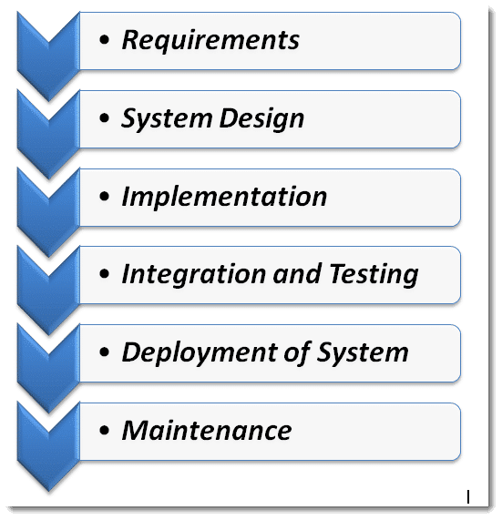

Figure 1

### **Sequential Phases in the Waterfall Model**

* **Requirements:**The first phase involves understanding what needs to design and what is its function, purpose, etc. Here, the specifications of the input and output or the final product are studied and marked.

* **System Design:** The requirement specifications from the first phase are studied in this phase and system design is prepared. System Design helps in specifying hardware and system requirements and also helps in defining overall system architecture. The software code to be written in the next stage is created now.

* **Implementation:** With inputs from system design, the system is first developed in small programs called units, which are integrated into the next phase. Each unit is developed and tested for its functionality which is referred to as Unit Testing.

* **Integration and Testing:** All the units developed in the implementation phase are integrated into a system after testing of each unit. The software designed, needs to go through constant software testing to find out if there are any flaw or errors. Testing is done so that the client does not face any problem during the installation of the software.

* **Deployment of System:** Once the functional and non-functional testing is done, the product is deployed in the customer environment or released into the market.

* **Maintenance:** This step occurs after installation, and involves making modifications to the system or an individual component to alter attributes or improve performance. These modifications arise either due to change requests initiated by the customer, or defects uncovered during live use of the system. The client is provided with regular maintenance and support for the developed software.

**Software requirements: -**

1.OS: Windows 7 or above

2. EDITOR: VS code

3. LIBRARY FILES: Session, Helper

4. PLATFORM: PHP Framework

5. TECHNOLOGIES USED: PHP, JAVASCRIPT

6. DATABASE- MySQL

**Hardware requirements:-**

1. An android phone/tablet

2. GPU: intel HD 5000 or above

3. CPU: intel 5005U @2.00gz or above

4. RAM: 4Gb or above

**CHAPTER 2: DESIGN SPECIFICATION**

**ER Diagram:-**

Entity relationship diagram displays the relationships of entity set stored in a database. In other words, we can say that ER diagrams help you to explain the logical structure of databases. At first look, an ER diagram looks very similar to the flowchart. However, ER Diagram includes many specialized symbols, and its meanings make this model unique.

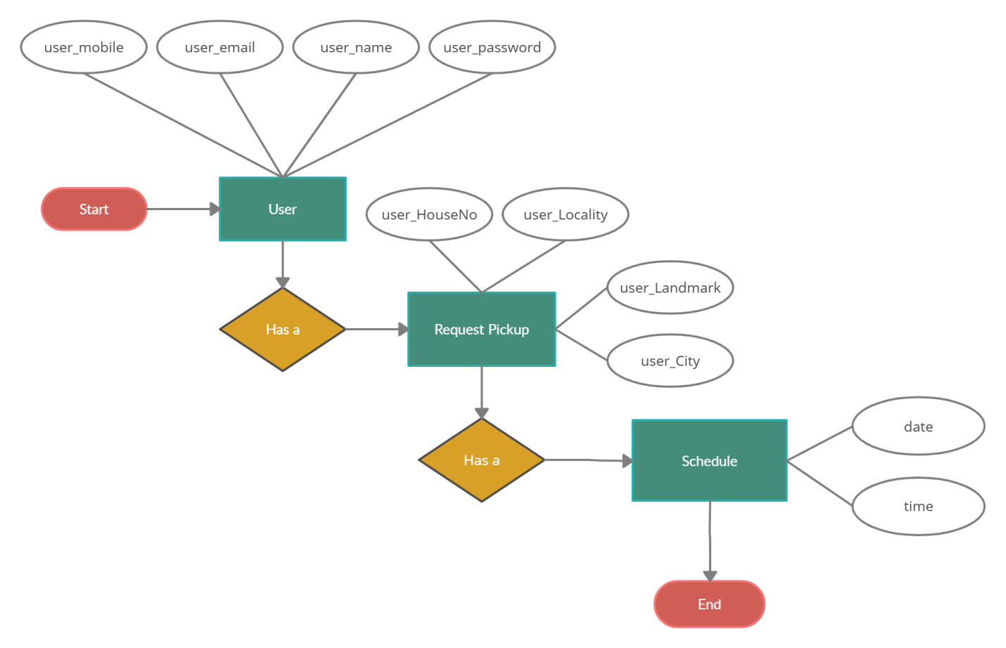

Figure 2

**DATA FLOW DIAGRAM:**

A data-flow diagram (DFD) is a way of representing a flow of data of a process or a system (usually an information system). The DFD also provides information about the outputs and inputs of each entity and the process itself. A data-flow diagram has no control flow, there are no decision rules and no loops. Specific operations based on the data can be represented by a flowchart.

**DFD LEVEL 0:**

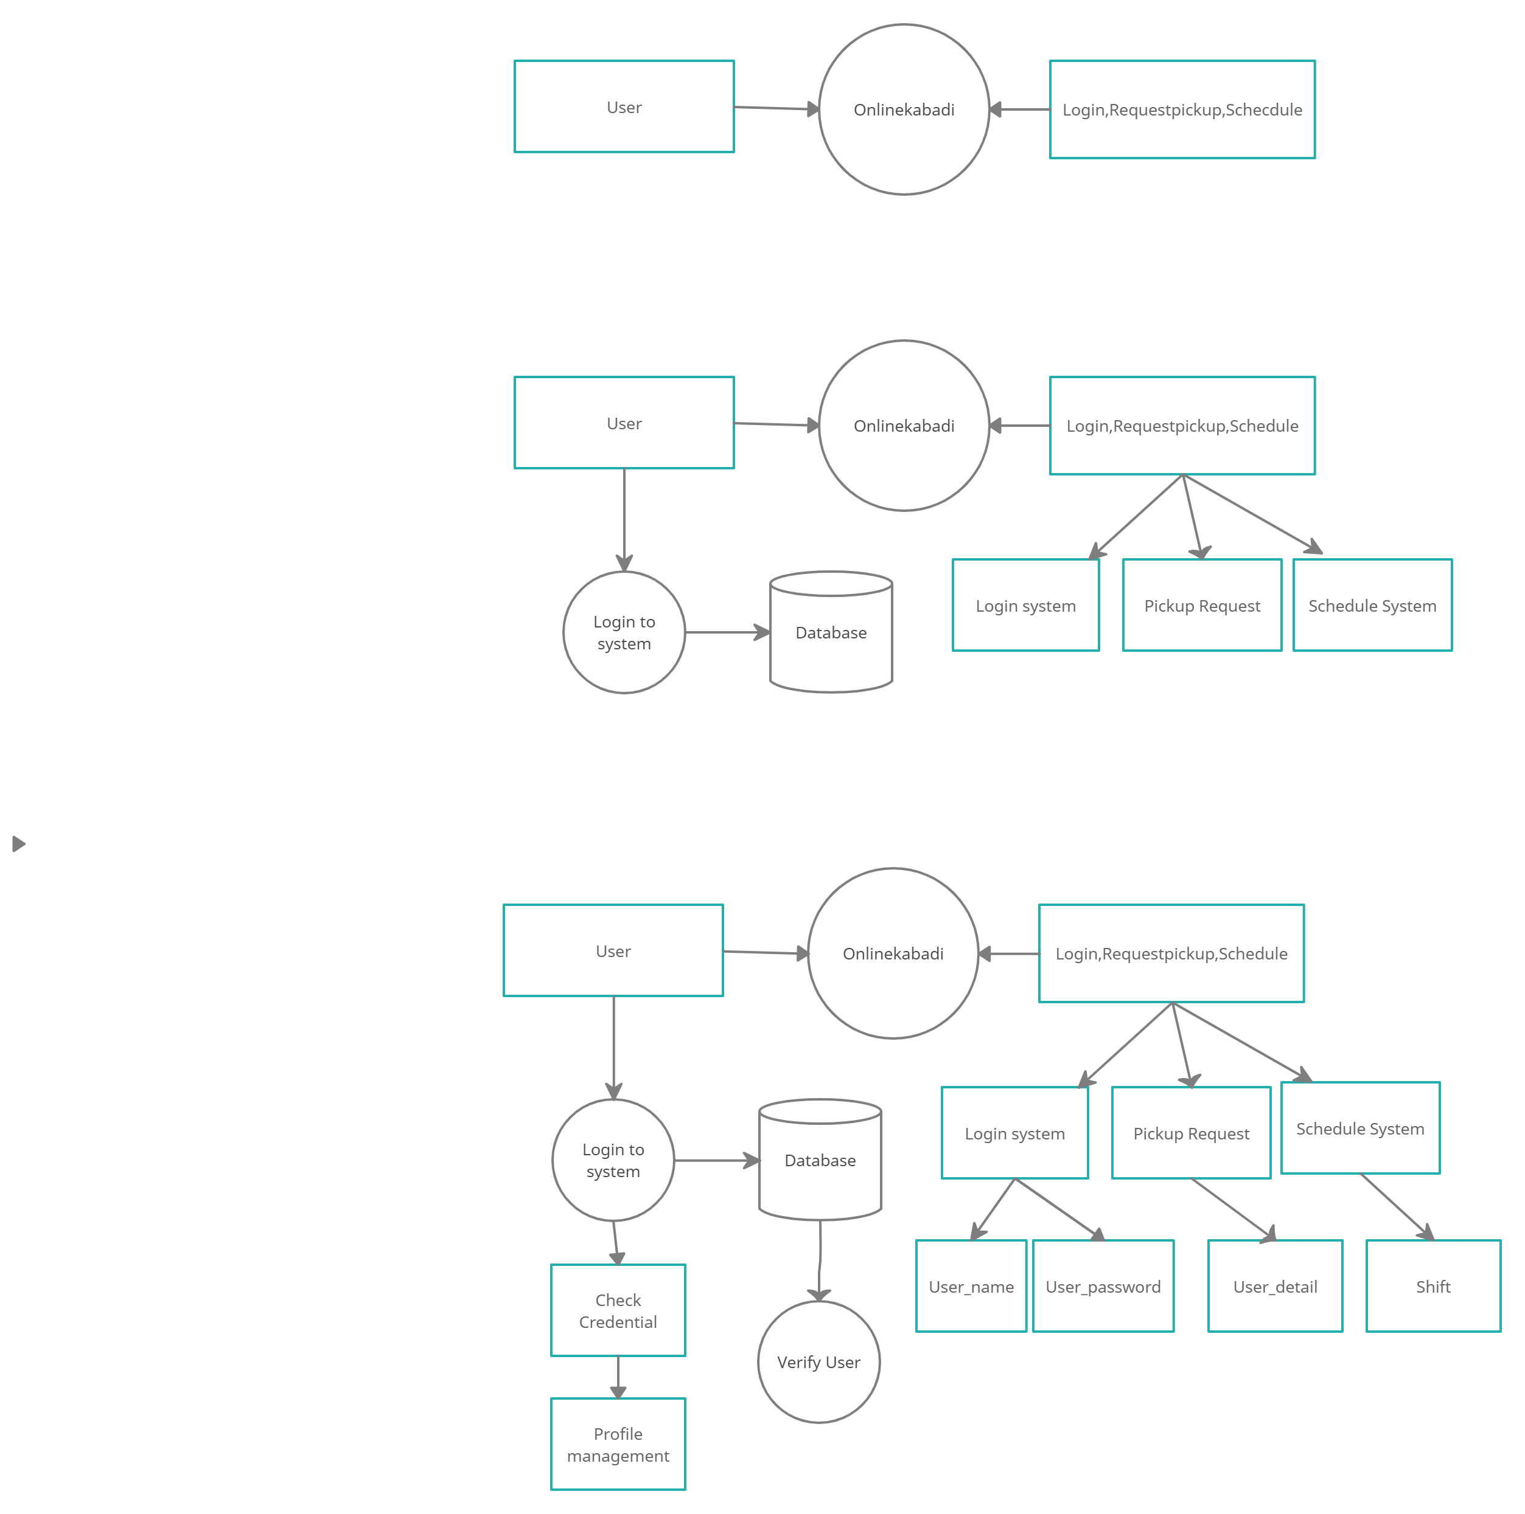

Figure 3

**DFD LEVEL 1:**

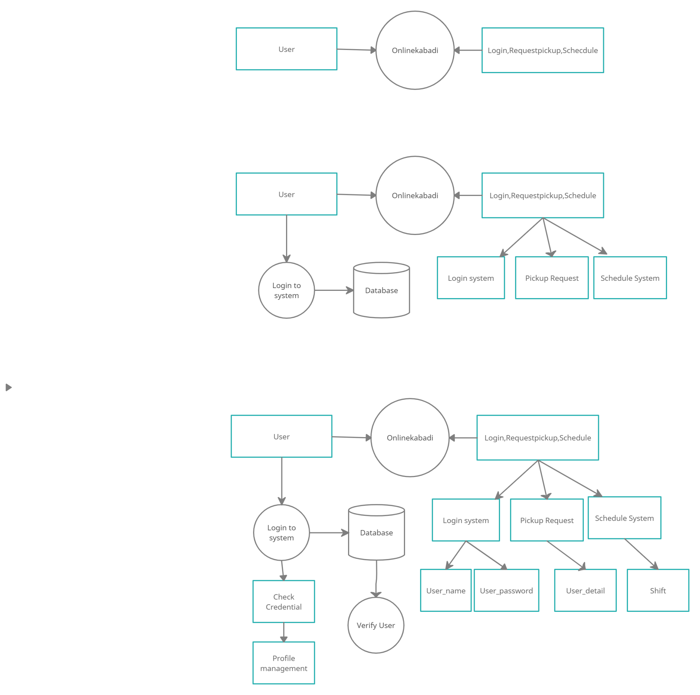

Figure 4

**DFD LEVEL 2:**

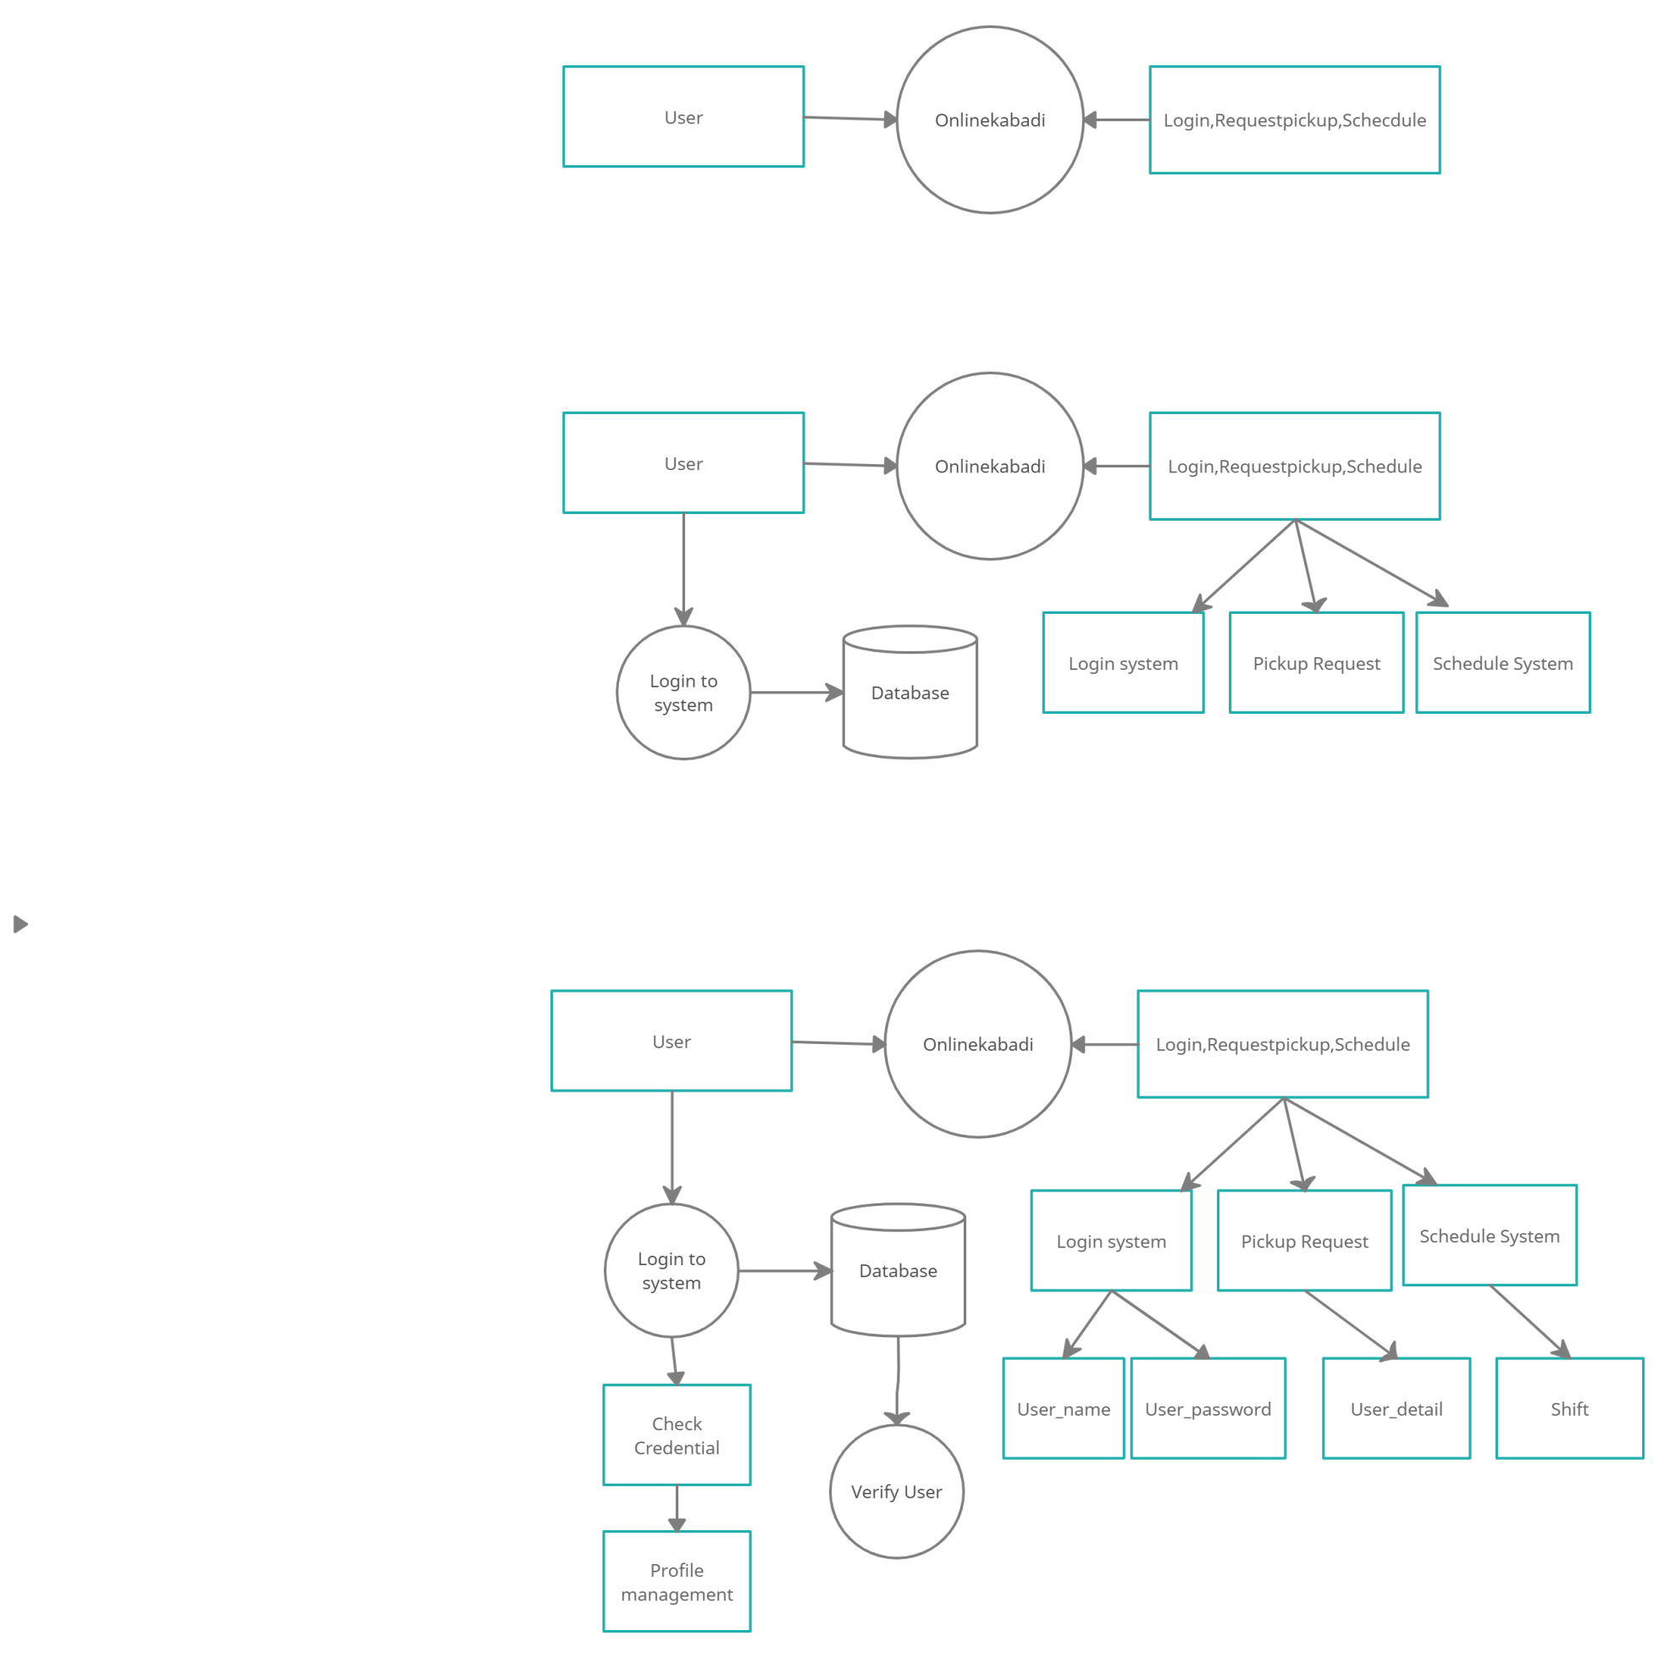

Figure

**SEQUENCE DIAGRAM:** A sequence diagram shows object interactions arranged in time sequence. It depicts the objects and classes involved in the scenario and the sequence of messages exchanged between the objects needed to carry out the functionality of the scenario. Sequence diagrams are typically associated with use case realizations in the Logical View of the system under development. Sequence diagrams are sometimes called event diagrams or event scenarios.

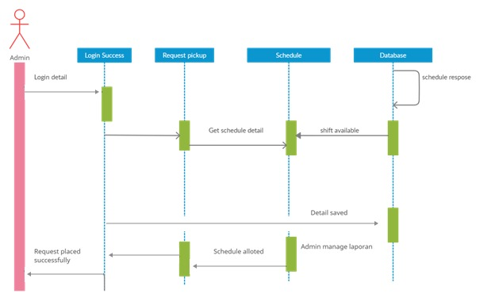

Figure 6

**CLASS DIAGRAM:**

A class diagram in the Unified Modeling Language (UML) is a type of static structure diagram that describes the structure of a system by showing the system's classes, their attributes, operations (or methods), and the relationships among objects. The class diagram is the main building block of object-oriented modeling. It is used for general conceptual modeling of the structure of the application, and for detailed modeling translating the models into programming code. Class diagrams can also be used for data modeling. [1] The classes in a class diagram represent both the main elements, interactions in the application, and the classes to be programmed.

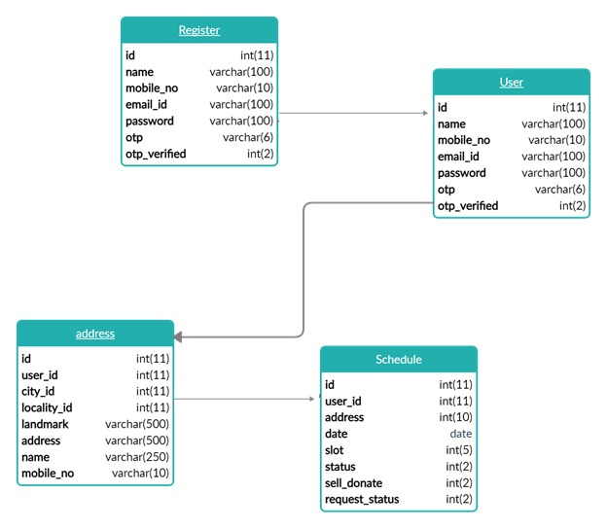

Figure

**ACTIVITY DIAGRAM:**

Activity diagrams are graphical representations of workflows of stepwise activities and actions with support for choice, iteration and concurrency. In the Unified Modeling Language, activity diagrams are intended to model both computational and organizational processes (i.e., workflows), as well as the data flows intersecting with the related activities.

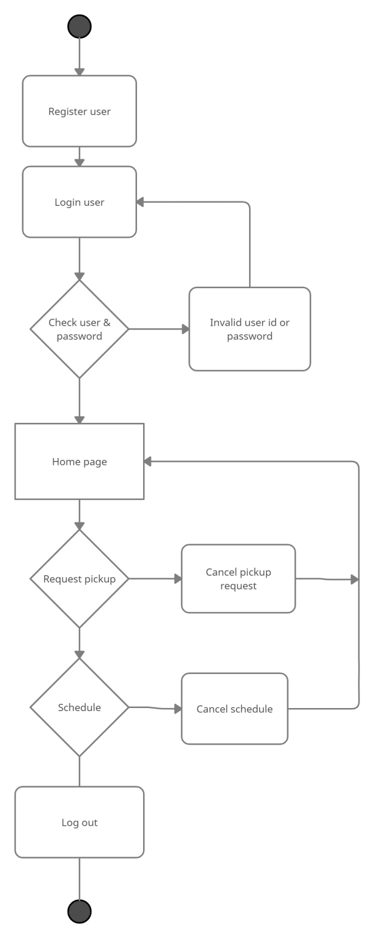

Figure 8

**MODULES:**

**Module 1: login and register for customer:**

The aim of the first module is to implement signup, login and forget password features for the customer and store the respective data in Database.

**Module 2:** **create profiles and verification:**

The second module will focus on implementing customer profiles feature which will enable customer to create and modify their personalized pages i.e., profiles which will be viewed after login.

**Module 3:** **Scrap catalogue**

This module will show customer scrap price detail. Price shown on price page are not fixed. Price may vary as per the market variation.

**Module 4: request for order**

This module will help customer to request pickup and ask for the detail that customer have to provide.

**Module 5: admin panel**

This module will have control over action of customer and admin. Using admin panel we can add/remove scrap and price of each scrap.

**Design Considerations**

The judicial information and e-advocacy app is designed with the following considerations:

● **Compatibility -** The software is able to operate with other products that are designed for interoperability with another product. For example, a piece of software may be backward-compatible with an older version of itself.

**● Extensibility** - New capabilities can be added to the software without major changes to the underlying architecture.

● **Modularity** - the resulting software comprises well defined, independent components which leads to better maintainability. The components could be then implemented and tested in isolation before being integrated to form a desired software system. This allows division of work in a software development project.

● **Fault-tolerance** - The software is resistant to and able to recover from component failure.

● **Maintainability** - A measure of how easily bug fixes or functional modifications can be accomplished. High maintainability can be the product of modularity and extensibility.

● **Reliability (Software durability)** - The software is able to perform a required function under stated conditions for a specified period of time.

● **Reusability** - The ability to use some or all of the aspects of the preexisting software in other projects with little to no modification.

● **Robustness** - The software is able to operate under stress or tolerate unpredictable or invalid input. For example, it can be designed with resilience to low memory conditions.

● **Security** - The software is able to withstand and resist hostile acts and influences.

● **Usability** - The software user interface must be usable for its target user/audience. Default values for the parameters must be chosen so that they are a good choice for the majority of the users.

● **Performance** - The software performs its tasks within a time-frame that is acceptable for the user, and does not require too much memory.

● **Portability** - The software should be usable across a number of different conditions and environments.

● **Scalability** - The software adapts well to increasing data or number of users.

**CHAPTER 3**

**Module 1: - User Registration and login**

The aim of the first module is to gather user details from the user and to store the user details and credentials in the MySQL database that lets you store and sync data between your users in real-time. A registered **user** is a **user** of a website, program, or other system who has previously registered. Registered users normally provide some sort of credentials (such as a **username** or e-mail address, and a password) to the system in order to prove their identity: this is known as logging in.

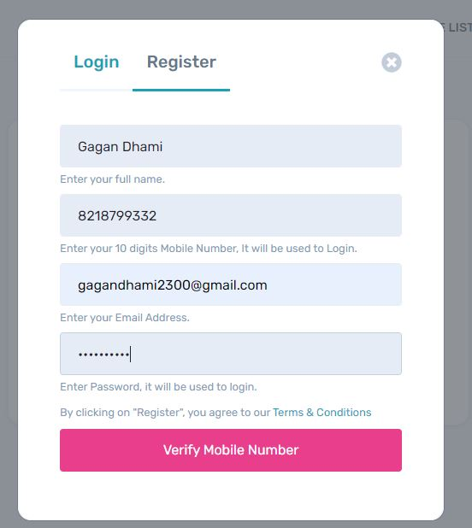

Figure 9

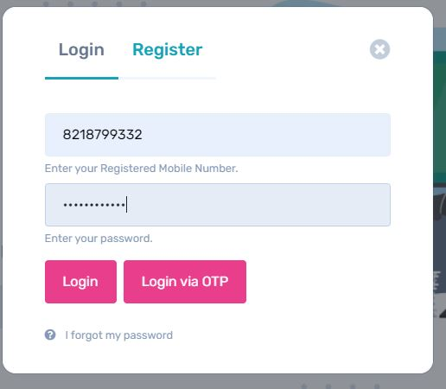

Figure 10

**Module 2: - Profile management**

The User Profile Management feature provides central management for employee-specific data and settings stored in profiles. The goal of User Profile Management is to speed up the desktop logon and logoff process on Desktop. It is a web-based tool to organize research activities carried out by a researcher such as interests, skills, experience, expertise, mentor, projects, publications, etc.

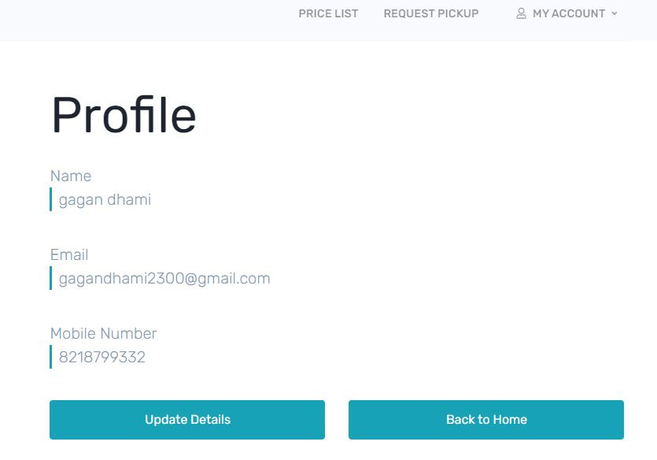

Figure 11

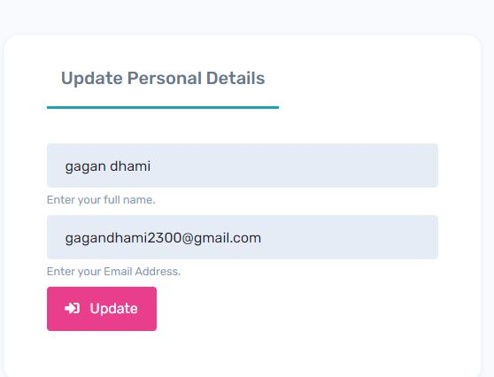

Figure 12

**Module 3: Request for order**

### Register or verify your address - Feel free to sell scrap to onlinekabadi.in and raise your contribution towards green earth and a better planet. Easy to schedule, date and time - Give us a favor to put your scrap in the right place. We are happy to Buy your scrap and pay you a better price.

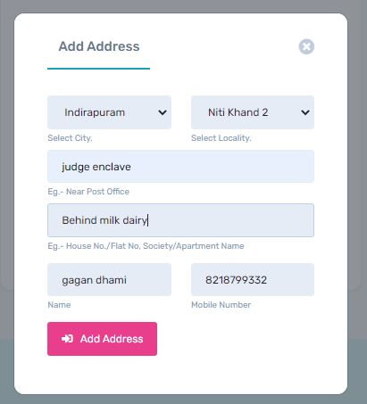

Figure 14

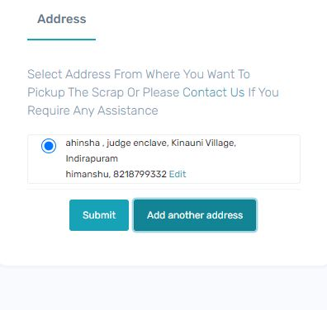

Figure 15

**Module 5: Admin Panel**

It's an **admin**-specific platform in an application that allows for access and manipulation of data within the user interface of the site. ... Functioning without an **admin panel** can lead to a lack of insight into your data, and add greater difficulty for the testing team.

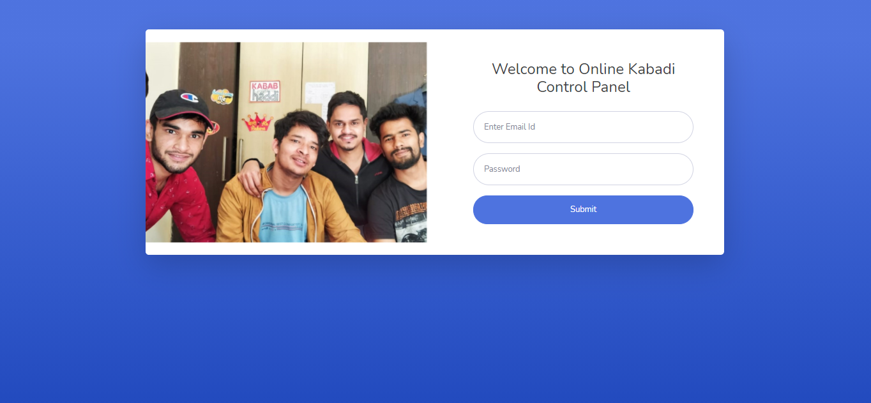

Figure 16

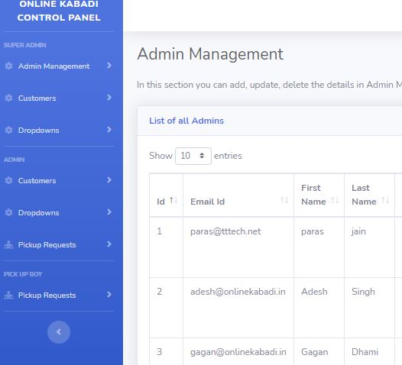

Figure 17

**References**

* https://codeigniter.com/
* https://getbootstrap.com/
* https://themes.getbootstrap.com/
* https://www.w3schools.com/js/DEFAULT.asp
* https://www.w3schools.com/php/default.asp
* https://www.w3schools.com/sql/default.asp